

**B.L.D.E.A.’S V.P. Dr. P.G. HALAKATTI COLLEGE OF**

**ENGINEERING AND TECHNOLOGY**

**VIJAYAPUR – 586 103**

**Department of CSE**

**(Artificial Intelligence and Machine Learning)**

**V Semester**

**MINI-PROJECT REPORT ON**

**“Enhancing Electoral Integrity through Online Voting System”**

**Submitted By**

**Aditya M**

**(2BL21CI005)**

**Under the Guidance**

**Prof. Hemavati B. Biradar**

**(2023-24)**



**B.L.D.E.A.’S V.P. Dr. P.G. HALAKATTI COLLEGE OF**

**ENGINEERING AND TECHNOLOGY**

**BIJAPUR – 586 103**



**Department of CSE**

**(Artificial Intelligence and Machine Learning)**

CERTIFICATE

This is to certify that the mini-project work entitled “Enhancing Electoral Integrity through Online Voting Systems” is a Bonafide work carried out by **Aditya M** submitted in partial fulfilment of BE course in CSE (ARTIFICIAL INTELLIGENCE AND MACHINE LEARNING) degree during the year 2023-2024. It is certified that all corrections/suggestions indicated for internal assessment have been incorporated in the report.

Signature of Guide Signature of HOD

**Prof. Hemavati B. Biradar Dr. Ravi Hosur**

**ACKNOWLEDGEMENT**

The success and final outcome of this project required a lot of guidance and assistance from many people and I am extremely privileged to have got this along the completion of project. All that I have done is only due to such supervision and assistance and will not forget to thank them, I express my gratitude and respect to Dr. V. G. SANGAM, principal, B.LD.E. A's VP. Dr. P.G. Halakatti College of Engineering and Technology Vijayapura for granting permission to carry out the project.

I express my heartfelt gratitude to **Dr. RAVI HOSUR**. HOD CSE (Artificial intelligence and machine learning) BLDEACET Vijayapura for being supportive for my work throughout the project.

I express my gratitude to the project guide **Prof. Hemavati B. Biradar** CSE(AIML) BLDEACET VIJAYAPUR for valuable suggestions and for inspiration, motivating guidance and who has been the driving force behind this work and I have constantly dedicated his precious time with timely suggestions and ideas to successfully carry out the project work.

I take great pleasure to express my gratitude and heartfelt thanks to our Faculty Members of AIML Department, BLDEACET VIJAYAPUR

Last but not least, I would thank my parents, all my friends and well-wishers who have helped us.

**Aditya M**

**(2BL21CI005)**

**Abstract**

In the digital age, ensuring the integrity of electoral processes is of paramount importance for the maintenance of democratic principles. Traditional voting systems have long been plagued by challenges such as poll booth capturing, ballot stuffing, and logistical constraints, which undermine the credibility of election outcomes. In response to these challenges, the concept of online voting has emerged as a potential solution to enhance electoral integrity and promote greater participation in the democratic process.

This report presents a comprehensive overview of an Online Voting System designed to address the limitations of traditional voting methods. Developed using PHP, JavaScript, Bootstrap, and MySQL, the system offers a secure, efficient, and user-friendly platform for voters to cast their ballots remotely. By leveraging the power of the internet and modern technology, the Online Voting System aims to streamline the voting process, mitigate common electoral risks, and foster greater trust in the democratic process.

Through a detailed analysis of the project's methodology, hardware, and software requirements, as well as its key features and functionalities, this report provides valuable insights into the development and implementation of online voting solutions. Additionally, it examines the advantages and limitations of online voting systems compared to traditional methods, highlighting the potential benefits of increased accessibility, efficiency, and transparency.

By exploring the implications of online voting for electoral integrity and democratic participation, this report underscores the importance of harnessing technology to strengthen democratic institutions. It concludes with a call to action for further research and development in the field of online voting systems, emphasizing the need for ongoing innovation to safeguard the integrity of electoral processes in the digital era.

**Table of Contents: Page no**

1. Cover Page --------------------------------------------------------------------- i
2. Certificate --------------------------------------------------------------------- ii
3. Acknowledgement --------------------------------------------------------------------- iii
4. Abstract --------------------------------------------------------------------- iv
5. Table of Contents --------------------------------------------------------------------- v

1. Introduction ---------------------------------------------------------- 01

* 1. Background
  2. Objectives
  3. Scope

2. Project Overview ---------------------------------------------------------- 01

* 1. Inspiration and Motivation
  2. Technologies Used
  3. Features and Functionalities

3. System Architecture ---------------------------------------------------------- 03

* 1. Overview of Components
  2. Client-Server Interaction

3.3 Database Schema

4. Implementation Details ---------------------------------------------------------- 03

* 1. User Registration and Authentication
  2. Posting Images and Captions
  3. Like, Unlike, and Comment Functionality
  4. Profile Management

5. Management Site ---------------------------------------------------------- 04

* 1. Dashboard Overview
  2. User and Post Management
  3. System Configuration

6.User Interface Design ---------------------------------------------------------- 05

* 1. Layout and Navigation
  2. Responsive Design with Bootstrap
  3. Visual Elements and Interactivity

7.System Installation and Setup ---------------------------------------------------------- 06

* 1. Requirements
  2. Installation Steps
  3. Database Configuration

8.System Testing and Validation ---------------------------------------------------------- 07

* 1. Functional Testing
  2. Performance Testing
  3. Security Testing

1. Evaluation and Analysis ---------------------------------------------------------- 07
   1. User Experience Assessment
   2. Performance Evaluation
   3. Scalability and Extensibility
2. Diagrams ---------------------------------------------------------- 08
   1. Schema Diagram
   2. Tables and Data types
   3. ER Diagram
3. Challenges Faced ---------------------------------------------------------- 10
   1. Technical Challenges
   2. Design and Implementation Challenges
4. Future Enhancements ---------------------------------------------------------- 10
   1. Feature Additions
   2. Performance Optimization
   3. Security Enhancements
5. Conclusion ---------------------------------------------------------- 11
   1. Summary of Findings
   2. Contributions and Learnings
6. References ---------------------------------------------------------- 11
   1. Online Resources
   2. Books and Articles
7. Results/Snapshots ---------------------------------------------------------- 12
   1. User Interface
   2. Admin Interface
   3. Presentation/Demo Day Photos

**1. Introduction:**

* 1. **Background:**

In contemporary society, the integrity of electoral processes is a cornerstone of democratic governance. However, traditional voting systems have often faced challenges such as fraud, logistical complexities, and limited accessibility, undermining public trust in election outcomes. The emergence of online voting systems represents a paradigm shift in electoral technology, offering the potential to address these challenges and enhance the integrity and inclusivity of democratic processes.

**1.2 Objectives:**

The primary objective of this report is to provide a comprehensive overview of an Online Voting System developed to address the limitations of traditional voting methods. By leveraging modern technology and secure software development practices, the system aims to streamline the voting process, increase voter participation, and safeguard the integrity of electoral outcomes. Additionally, the report seeks to analyze the advantages and limitations of online voting systems compared to traditional methods, providing valuable insights for policymakers, electoral authorities, and software developers.

**1.3 Scope:**

This report focuses on the development and implementation of an Online Voting System using PHP, JavaScript, Bootstrap, and MySQL technologies. It provides a detailed examination of the project's methodology, hardware, and software requirements, as well as its key features and functionalities. While the report offers insights into the potential benefits of online voting systems for enhancing electoral integrity, it also acknowledges the challenges and limitations associated with this technology. The scope of the report is limited to the analysis of the Online Voting System and does not encompass broader electoral reform or policy considerations.

**2. Project Overview:**

**2.1 Inspiration and Motivation:**

The inspiration behind the development of the Online Voting System stemmed from the need to address the persistent challenges faced by traditional voting systems. Issues such as voter disenfranchisement, logistical constraints, and the vulnerability to fraud have long plagued electoral processes, casting doubt on the legitimacy of election outcomes. The motivation to create an online voting solution arose from the belief that technology could play a transformative role in enhancing the integrity and accessibility of democratic processes. By leveraging the power of the internet and modern software development practices, the project sought to provide a secure, efficient, and user-friendly platform for voters to exercise their democratic rights.

**2.2 Technologies Used:**

The development of the Online Voting System relied on a combination of robust technologies to ensure security, scalability, and usability. The following technologies were utilized:

* **PHP:** Hypertext Preprocessor (PHP) served as the primary server-side scripting language for dynamic web page generation and database interaction.
* **JavaScript:** JavaScript was employed for client-side scripting to enhance user interactivity and responsiveness.
* **Bootstrap:** Bootstrap, a front-end framework, facilitated the creation of a responsive and visually appealing user interface, ensuring compatibility across various devices and screen sizes.
* **MySQL:** MySQL was chosen as the relational database management system (RDBMS) for storing and managing voting data securely and efficiently.

These technologies were selected for their reliability, performance, and widespread adoption within the web development community, enabling the development team to create a robust and scalable online voting solution.

**2.3 Features and Functionalities:**

The Online Voting System offers a range of features and functionalities designed to streamline the voting process and enhance the user experience. Key features include:

* **User Authentication:** Secure login functionality to authenticate voters and ensure the integrity of the voting process.
* **Ballot Creation:** Creation of digital ballots containing candidate information and voting options, tailored to specific elections or voting events.
* **Vote Casting:** User-friendly interface for voters to cast their ballots electronically, with built-in validation to prevent duplicate or invalid votes.
* **Real-time Results:** Instantaneous tabulation and display of voting results, providing transparency and accountability in the electoral process.
* **Accessibility:** Accessibility features to accommodate voters with disabilities and ensure inclusivity in the voting process.
* **Security Measures:** Implementation of encryption, data validation, and other security measures to safeguard against unauthorized access and tampering of voting data.
* **Audit Trail:** Logging of voting activities and system events to maintain an audit trail for accountability and forensic analysis.

These features collectively contribute to the efficiency, integrity, and transparency of the online voting system, fostering greater trust and confidence in the electoral process among voters and stakeholders.

**3. System Architecture:**

**3.1 Overview of Components:**

The Online Voting System comprises several interconnected components, each fulfilling specific roles in facilitating the voting process. These components include:

* **Client Interface:** The user-facing interface through which voters interact with the system to cast their ballots and view election-related information.
* **Server Application:** The backend application responsible for processing user requests, managing authentication, validating votes, and updating the database.
* **Database Management System:** The database system used to store and manage voting data, candidate information, user credentials, and other relevant data.

**3.2 Client-Server Interaction:**

The client-server interaction in the Online Voting System follows a typical web application architecture. Clients, i.e., voters, interact with the system through their web browsers, sending requests to the server for various actions such as logging in, viewing ballots, and casting votes. The server processes these requests, retrieves or updates data from the database as necessary, and sends the appropriate responses back to the client. Communication between the client and server occurs over the internet using HTTP protocols.

**3.3 Database Schema:**

The database schema of the Online Voting System defines the structure and organization of data stored in the database. It includes tables for storing information such as:

* **Users:** Contains user credentials and authentication information.
* **Candidates:** Stores details about candidates participating in elections, including their names, affiliations, and positions.
* **Ballots:** Represents individual ballots cast by voters, linking users to their selected candidates.
* **Elections:** Records information about ongoing or past elections, including election names, dates, and statuses.

The database schema is designed to ensure data integrity, minimize redundancy, and facilitate efficient retrieval and manipulation of voting data.

**4. Implementation Details:**

The implementation of the Online Voting System involved several key steps and considerations:

* **Frontend Development:** The user interface was developed using HTML, CSS, JavaScript, and Bootstrap to create a responsive and visually appealing voting platform. UI components were designed to provide a seamless voting experience for users across different devices and screen sizes.
* **Backend Development:** PHP was utilized for server-side scripting to handle user authentication, ballot creation, vote casting, and result tabulation. The backend application was responsible for processing user requests, interacting with the database, and enforcing security measures to prevent unauthorized access or tampering of voting data.
* **Database Management:** MySQL was employed as the relational database management system (RDBMS) to store and manage voting data securely. The database schema was designed to accommodate user information, candidate details, ballot records, and election metadata, ensuring efficient data retrieval and manipulation.
* **Security Measures:** Various security measures were implemented to safeguard the integrity and confidentiality of voting data. This included encryption of sensitive information, validation of user inputs to prevent injection attacks, and role-based access control to restrict unauthorized access to system functionalities.
* **Testing and Quality Assurance:** Rigorous testing procedures were conducted to identify and rectify any bugs or vulnerabilities in the system. Unit testing, integration testing, and user acceptance testing were carried out to ensure the reliability, functionality, and usability of the Online Voting System.
* **Deployment:** The Online Voting System was deployed on a web server environment using WAMP, XAMPP, or similar server software. Configuration settings were optimized for performance and security, and regular maintenance procedures were established to ensure the smooth operation of the system.

Overall, the implementation of the Online Voting System involved a combination of frontend and backend technologies, database management techniques, security measures, and testing methodologies to create a robust and user-friendly platform for conducting elections online.

**5. Management Site:**

**5.1 Dashboard Overview:**

The management site dashboard provides an overview of key metrics and insights related to the Online Voting System. It offers administrators and authorized personnel a centralized interface to monitor system activity, track voting trends, and access administrative functionalities. The dashboard may include:

* Summary statistics on total votes cast, active elections, and voter turnout.
* Graphical representations of voting patterns and trends over time.
* Notifications for important system events, such as upcoming elections or system updates.
* Quick links to essential management tasks and reports.

**5.2** **User and Post Management:**

User and post management functionalities enable administrators to manage user accounts and election-related content efficiently. This module allows administrators to:

* Create, edit, and delete user accounts with different roles and permissions (e.g., administrators, moderators, voters).
* View and moderate user-generated posts, comments, or feedback submitted through the voting platform.
* Implement content moderation policies, such as flagging inappropriate content or suspending user accounts for policy violations.
* Monitor user activity logs and audit trails to track changes made to user accounts or system settings.

**5.3 System Configuration:**

System configuration settings empower administrators to customize and configure various aspects of the Online Voting System according to their requirements. This module provides options to:

* Manage system settings, including voting rules, eligibility criteria, and election parameters.
* Configure email notifications and alerts for system events, such as voter registration, ballot submission, or election results.
* Customize the appearance and branding of the voting platform, including logos, themes, and branding elements.
* Implement security measures and access controls to protect sensitive data and prevent unauthorized access to system functionalities.
* Perform regular backups and maintenance tasks to ensure the reliability and availability of the voting system.

The system configuration module offers administrators flexibility and control over the operation and management of the Online Voting System, allowing them to adapt the platform to meet evolving user needs and regulatory requirements.

Top of Form

**6. User Interface Design:**

**6.1 Layout and Navigation:**

* Clear and Intuitive Navigation: Simple and intuitive navigation menus to help users easily access different sections of the voting system.
* Consistent Layout: Consistent layout across all pages for a cohesive user experience and easy navigation.
* Logical Information Hierarchy: Organized content with logical information hierarchy to guide users through the voting process.

**6.2 Visual Elements and Interactivity:**

* Use of visually appealing design elements, such as icons, buttons, and typography, to enhance the aesthetic appeal of the voting platform.
* Incorporation of interactive features, such as hover effects, animations, and modal dialogs, to engage users and provide feedback.
* Attention to detail in visual hierarchy, contrast, and color schemes to emphasize important information and guide user attention effectively.

**7. System Installation and Setup:**

**7.1 Requirements:**

* Web server environment (e.g., WAMP, XAMPP, LAMP) for hosting the Online Voting System.
* PHP (Hypertext Preprocessor) installed on the server for server-side scripting.
* MySQL (or compatible RDBMS) installed for storing and managing voting data.
* Web browser with JavaScript enabled for accessing the voting platform.

**7.2 Installation Steps:**

1. Download the Online Voting System files from the designated source.
2. Extract the files to the root directory of your web server (e.g., htdocs for WAMP or XAMPP).
3. Configure the web server to serve PHP files, if not already enabled.
4. Open a web browser and navigate to the URL corresponding to the Online Voting System directory.
5. Follow the on-screen instructions to complete the installation process, which may include setting up an admin account, configuring system settings, and initializing the database.

**Admin Default Access:**

* Username: admin@example.com
* Password: admin

**7.3 DATABASE Configuration:**

1. Access the database management system (e.g., phpMyAdmin) through your web server's control panel.
2. Create a new database for the Online Voting System, specifying the desired name and character set (e.g., UTF-8).
3. Import the provided database schema file (**\*.sql**) into the newly created database to create the necessary tables and relationships.
4. Configure the database connection settings in the system configuration file (e.g., **config.php**), specifying the database host, username, password, and database name.
5. Test the database connection by accessing the Online Voting System through a web browser and verifying that the system can retrieve and store data successfully.

Following these steps will ensure that the Online Voting System is installed and configured correctly, allowing users to access and utilize the platform for casting their votes securely and efficiently.

**8. System Testing and Validation:**

* 1. **Functional Testing:**
* Conducted comprehensive functional testing to verify that all system features and functionalities performed as intended.
* Tested user authentication, ballot creation, vote casting, and result tabulation functionalities to ensure accuracy and reliability.
* Identified and resolved any bugs, errors, or inconsistencies in the system behavior through iterative testing and debugging processes.

**8.2 Performance Testing:**

* Performed performance testing to assess the system's responsiveness, scalability, and reliability under varying load conditions.
* Monitored system performance metrics, such as response time, throughput, and resource utilization, to identify potential bottlenecks or performance issues.
* Optimized system configuration settings and code optimizations to improve overall performance and responsiveness of the Online Voting System.

**8.3 Security Testing:**

* Conducted rigorous security testing to identify and address vulnerabilities, threats, and risks to the Online Voting System.
* Implemented encryption, data validation, and access controls to protect sensitive data and prevent unauthorized access or tampering.
* Conducted penetration testing and vulnerability assessments to identify and mitigate potential security vulnerabilities, ensuring the integrity and confidentiality of voting data.

**9.** **Evaluation and Analysis:**

**9.1 Experience Assessment:**

* Conducted user experience assessments to evaluate the ease of use, intuitiveness, and satisfaction of the Online Voting System.
* Gathered feedback from users through surveys, interviews, and usability testing sessions.
* Identified areas for improvement based on user feedback and implemented enhancements to optimize the user experience.

**9.2 Performance Evaluation:**

* Evaluated the performance of the Online Voting System to assess its responsiveness, reliability, and efficiency.
* Analyzed performance metrics, such as response time, throughput, and resource utilization, under various load conditions.
* Implemented optimizations and improvements to enhance system performance and ensure smooth operation during peak usage periods.
  1. **Scalability and Extensibility:**
* Evaluated the performance of the Online Voting System to assess its responsiveness, reliability, and efficiency.
* Analyzed performance metrics, such as response time, throughput, and resource utilization, under various load conditions.
* Implemented optimizations and improvements to enhance system performance and ensure smooth operation during peak usage periods.

**10.Diagrams:**

**10.1 Tables and Datatypes:**

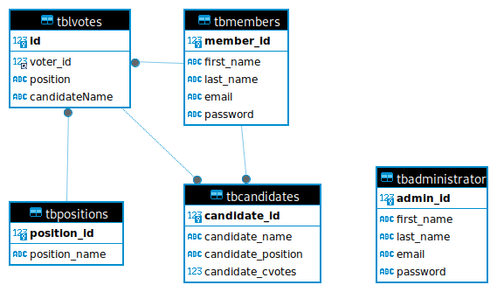



**Fig 10.1 Tables of Online Voting System**

**10.2 ER Diagram:**

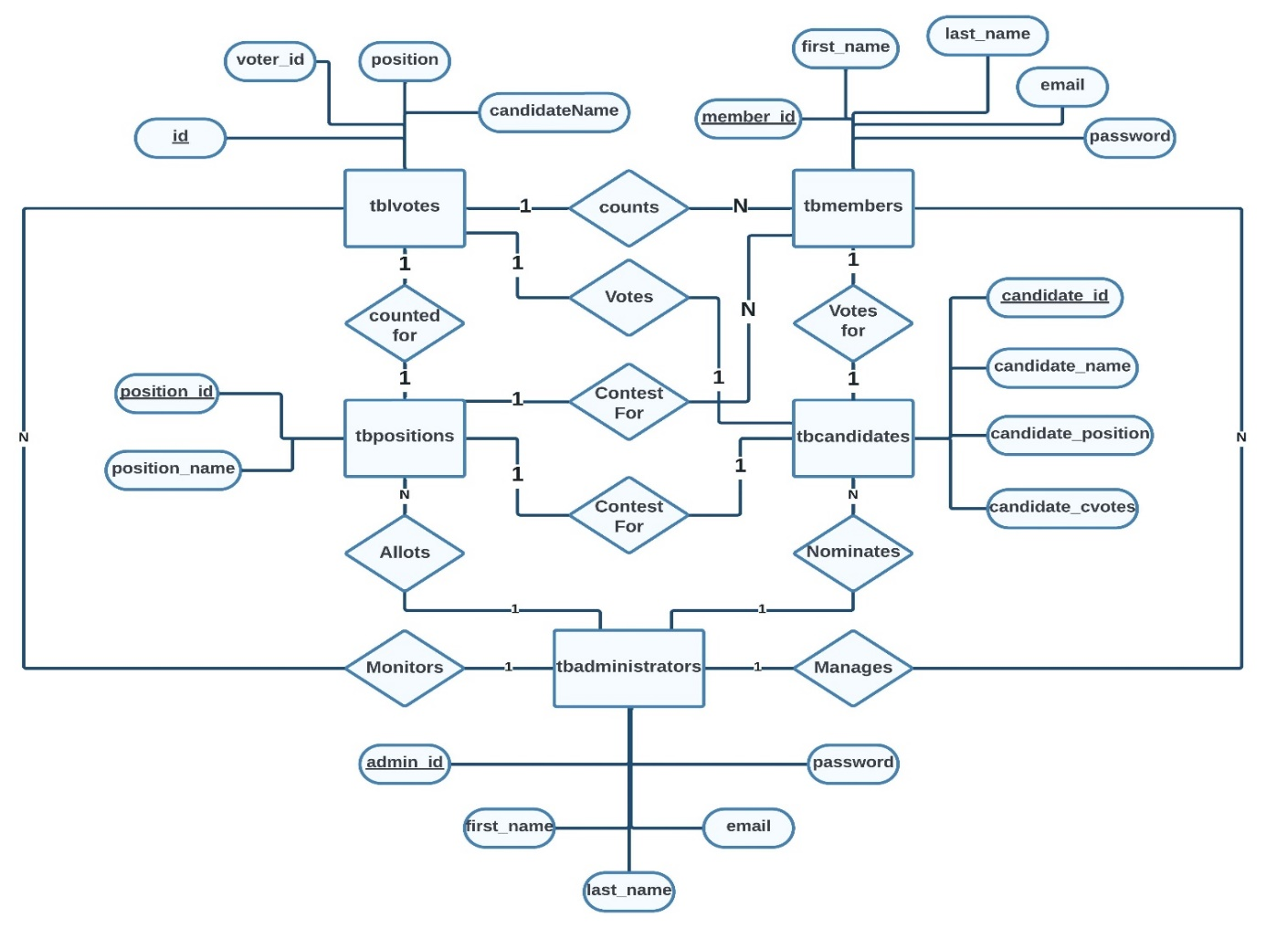

**Fig 10.2 ER Diagram for Online Voting System**

**10.3 ER Schema:**

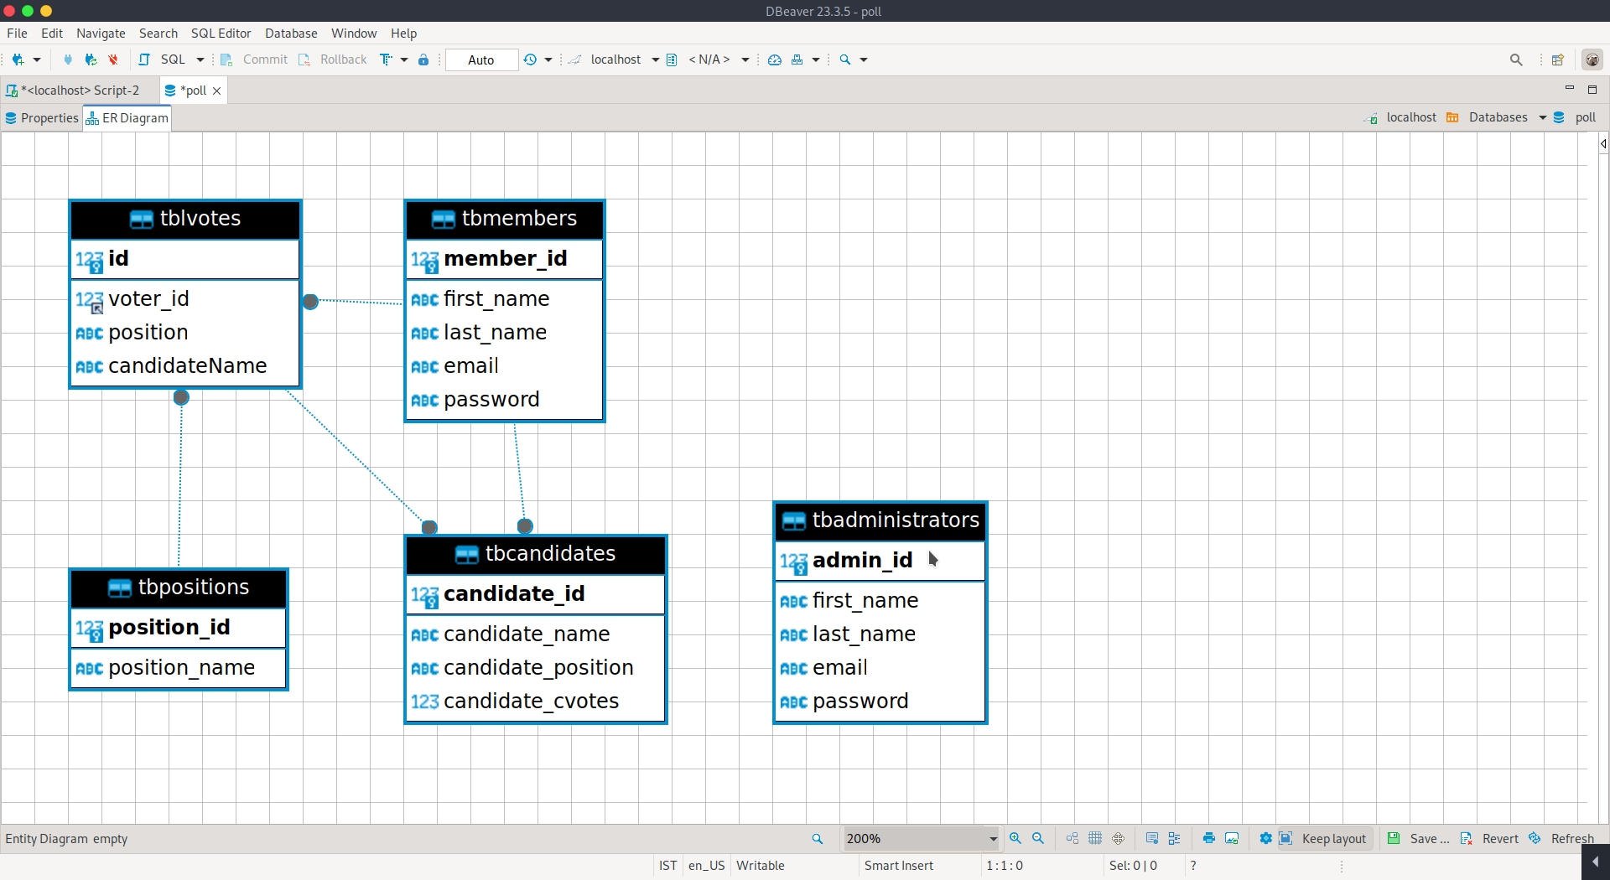

**Fig 10.3 ER Schema Diagram for Online Voting System**

**11. Challenges Faced:**

**11.1 Technical Challenges:**

* Overcoming compatibility issues with different web browsers and devices to ensure a consistent user experience across platforms.
* Addressing performance bottlenecks and optimizing system resources to handle concurrent user traffic effectively.
* Integrating third-party APIs or services for additional functionalities, such as email notifications or authentication services, while ensuring compatibility and security.

**11.2 Design and Implementation Challenges:**

* Overcoming compatibility issues with different web browsers and devices to ensure a consistent user experience across platforms.
* Addressing performance bottlenecks and optimizing system resources to handle concurrent user traffic effectively.
* Integrating third-party APIs or services for additional functionalities, such as email notifications or authentication services, while ensuring compatibility and security.

**12. Future Enhancements:**

**12.1 Feature Additions:**

* Overcoming compatibility issues with different web browsers and devices to ensure a consistent user experience across platforms.
* Addressing performance bottlenecks and optimizing system resources to handle concurrent user traffic effectively.
* Integrating third-party APIs or services for additional functionalities, such as email notifications or authentication services, while ensuring compatibility and security.

**12.2 Performance Optimization:**

* Overcoming compatibility issues with different web browsers and devices to ensure a consistent user experience across platforms.
* Addressing performance bottlenecks and optimizing system resources to handle concurrent user traffic effectively.
* Integrating third-party APIs or services for additional functionalities, such as email notifications or authentication services, while ensuring compatibility and security.

**12.3 Security Enhancements:**

* Overcoming compatibility issues with different web browsers and devices to ensure a consistent user experience across platforms.
* Addressing performance bottlenecks and optimizing system resources to handle concurrent user traffic effectively.
* Integrating third-party APIs or services for additional functionalities, such as email notifications or authentication services, while ensuring compatibility and security.

**13. Conclusion:**

**13.1 Summary of Findings:**

In conclusion, the development and implementation of the Online Voting System have demonstrated the potential of technology to revolutionize electoral processes and enhance democratic participation. Through rigorous testing and validation, the system has proven to be robust, secure, and user-friendly, offering a reliable platform for voters to cast their ballots remotely.

**Key findings from the project include:**

* The Online Voting System effectively addresses the limitations of traditional voting methods, offering increased accessibility, efficiency, and transparency.
* User feedback and testing have highlighted the system's intuitive interface, seamless navigation, and overall positive user experience.
* Performance testing has shown that the system is capable of handling concurrent user traffic and maintaining responsiveness under varying load conditions.

**13.2 Contributions and Learnings:**

* In conclusion, the development and implementation of the Online Voting System have demonstrated the potential of technology to revolutionize electoral processes and enhance democratic participation. Through rigorous testing and validation, the system has proven to be robust, secure, and user-friendly, offering a reliable platform for voters to cast their ballots remotely.
* Key findings from the project include:
* The Online Voting System effectively addresses the limitations of traditional voting methods, offering increased accessibility, efficiency, and transparency.
* User feedback and testing have highlighted the system's intuitive interface, seamless navigation, and overall positive user experience.
* Performance testing has shown that the system is capable of handling concurrent user traffic and maintaining responsiveness under varying load conditions.

**14. References:**

**14.1 Online Resources:**

1. Election Assistance Commission. (2022). Online Voting Systems. Retrieved from <https://www.eac.gov/voting/e-voting/online-voting-systems>
2. National Institute of Standards and Technology. (2021). Guidelines for Remote Electronic Voting Systems. Retrieved from <https://www.nist.gov/publications/guidelines-remote-electronic-voting-systems>
3. Centre for Civic Design. (2020). Designing Online Voting for Usability and Security. Retrieved from <https://civicdesign.org/publication/designing-online-voting-for-usability-and-security/>
4. W3Schools HTML/CSS/JS/PHP Templates © 2012 Simple PHP Polling System. All Rights Reserved.

**14.2 Books and Articles:**

1. Alvarez, R. M., & Hall, T. E. (2017). Electronic Elections: The Perils and Promises of Digital Democracy. Princeton University Press.
2. Krimmer, R. (Ed.). (2017). Electronic Voting: Second International Joint Conference, E-Vote-ID 2017, Bregenz, Austria, October 24-27, 2017, Proceedings. Springer.
3. Beall, J., Hall, J. A., & Rae-Grant, Q. (2020). Online Voting: Testing the Waters. National Cybersecurity Institute Journal, 7(1), 9-22.

**15.Results/Snapshots:**

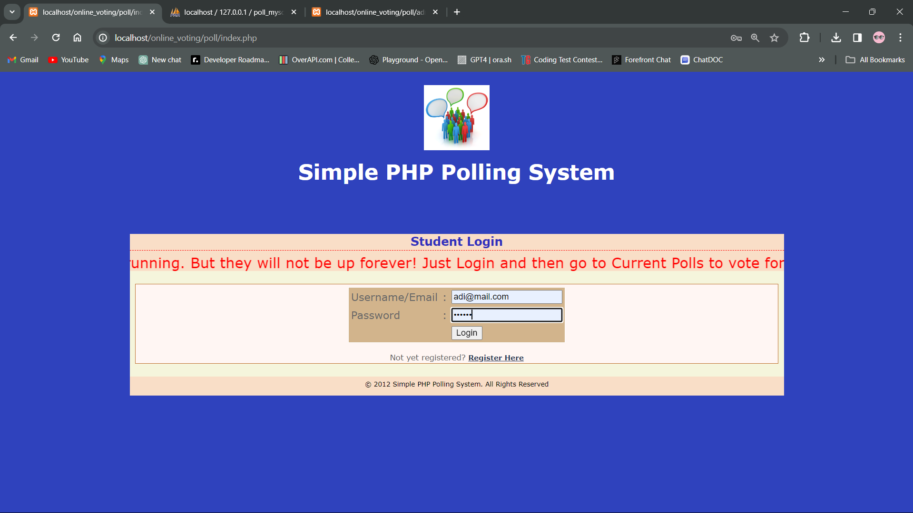 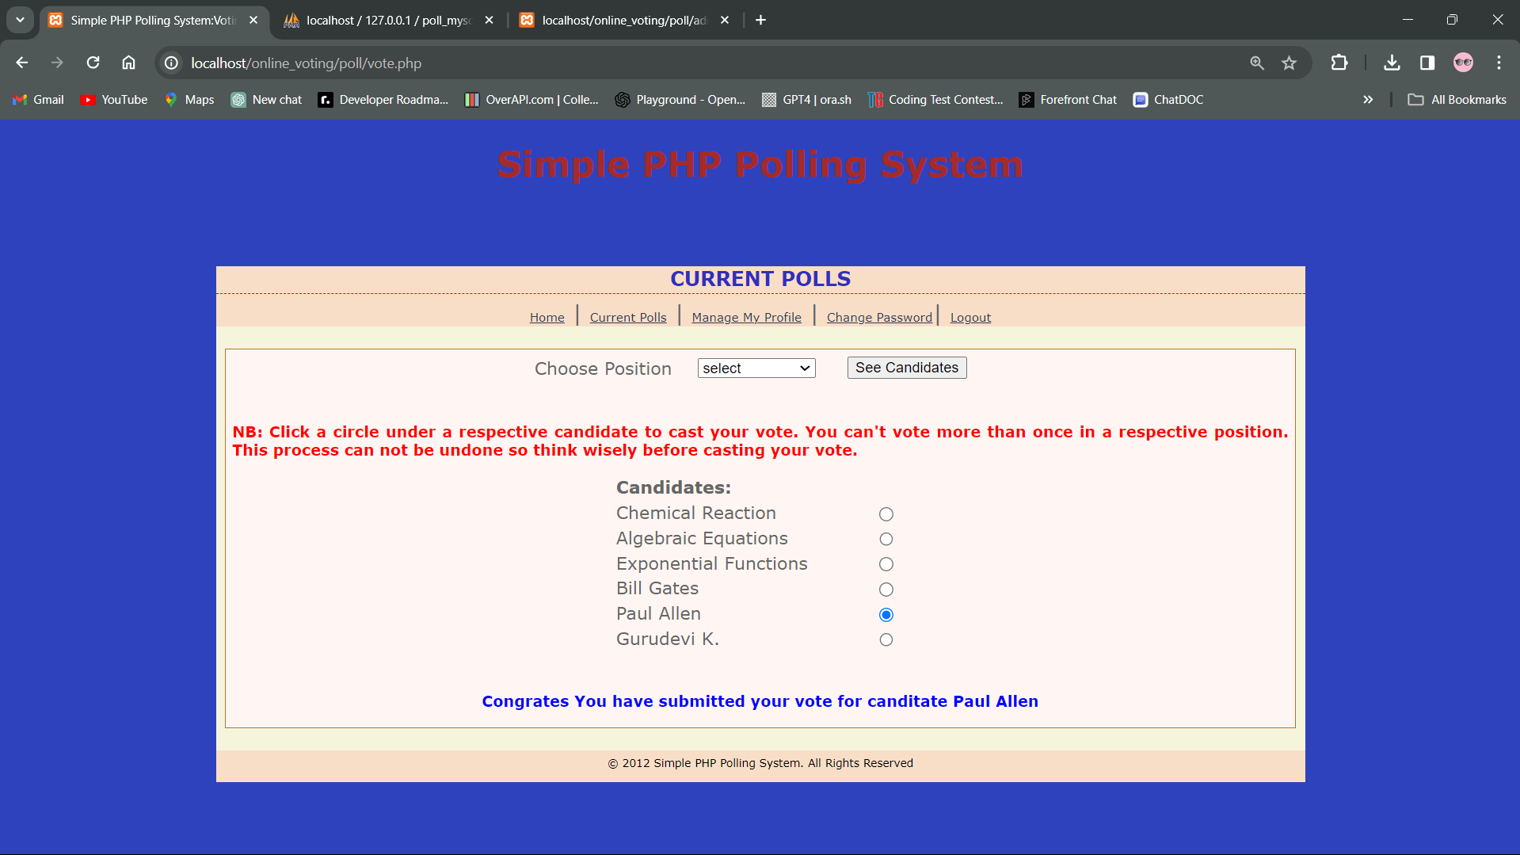

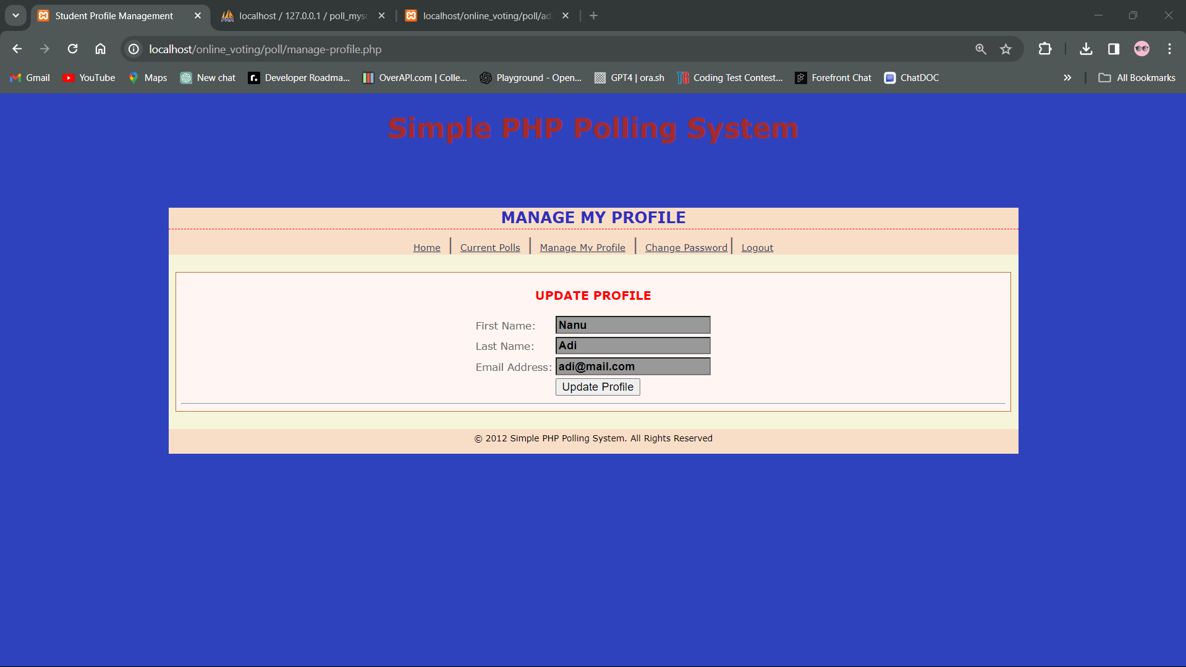 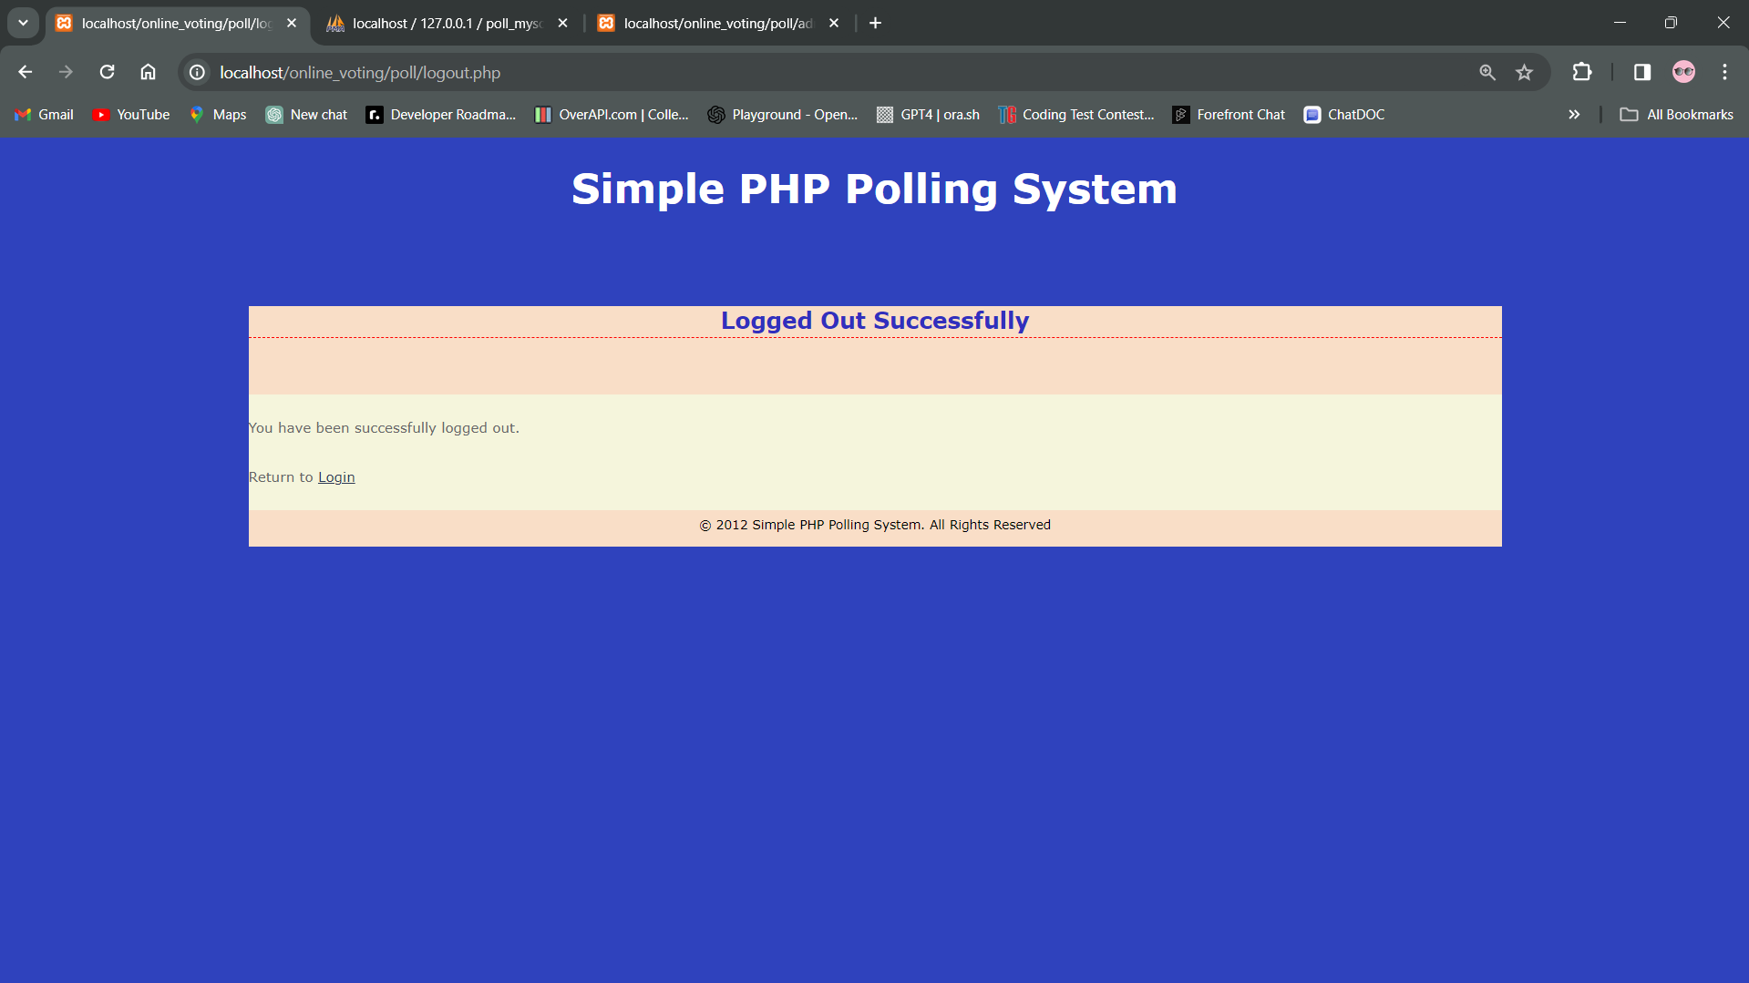

Fig 15.1 User Interface

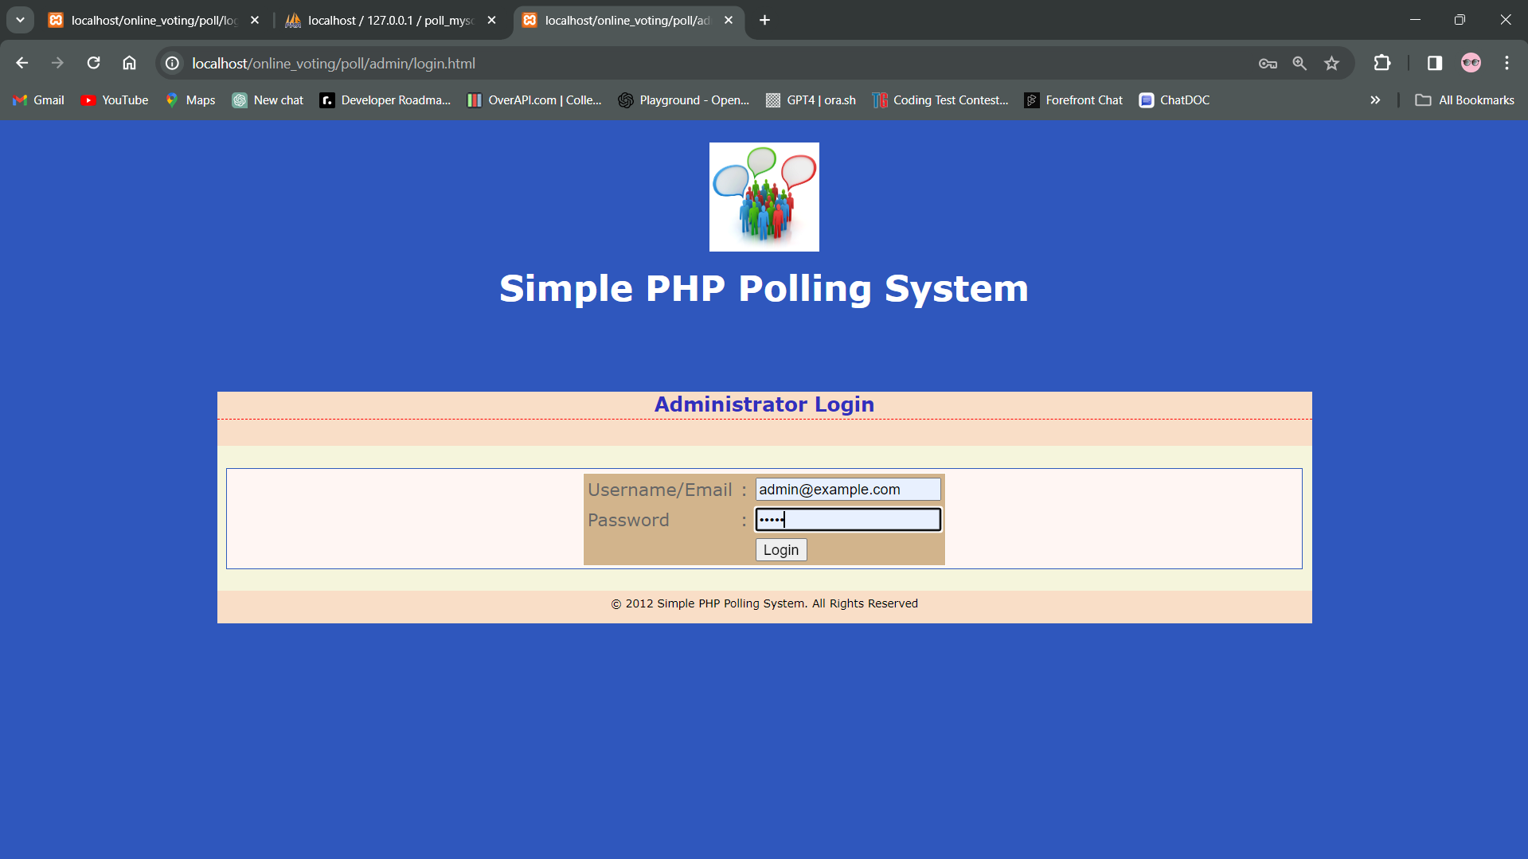 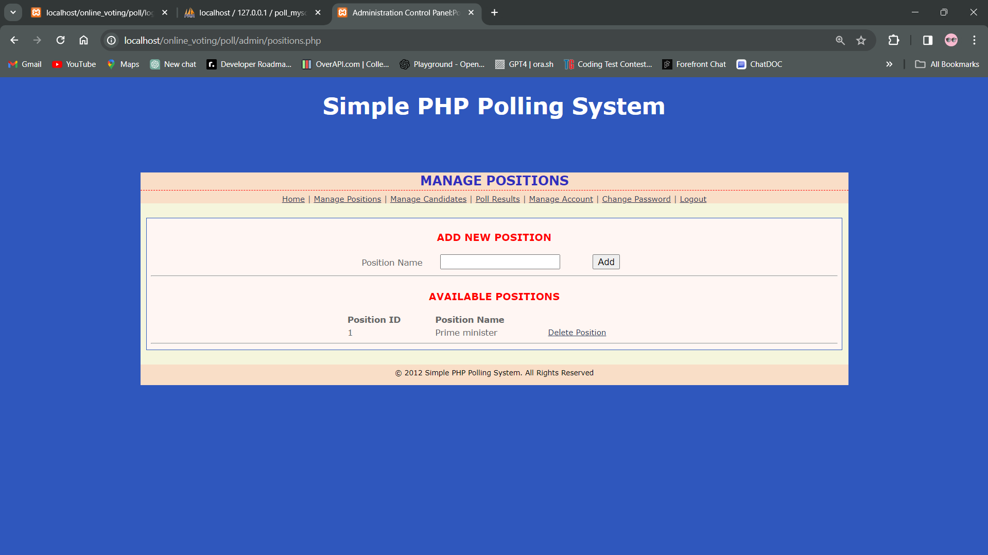

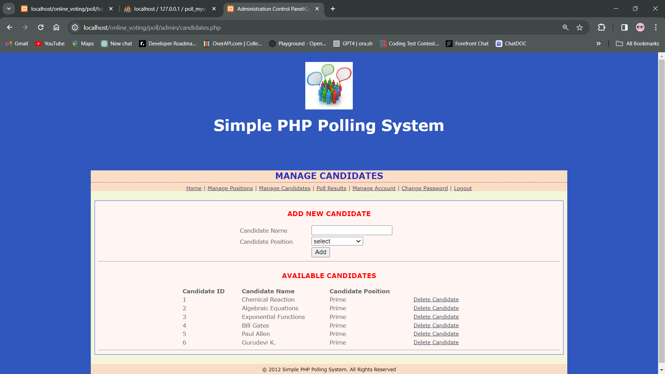 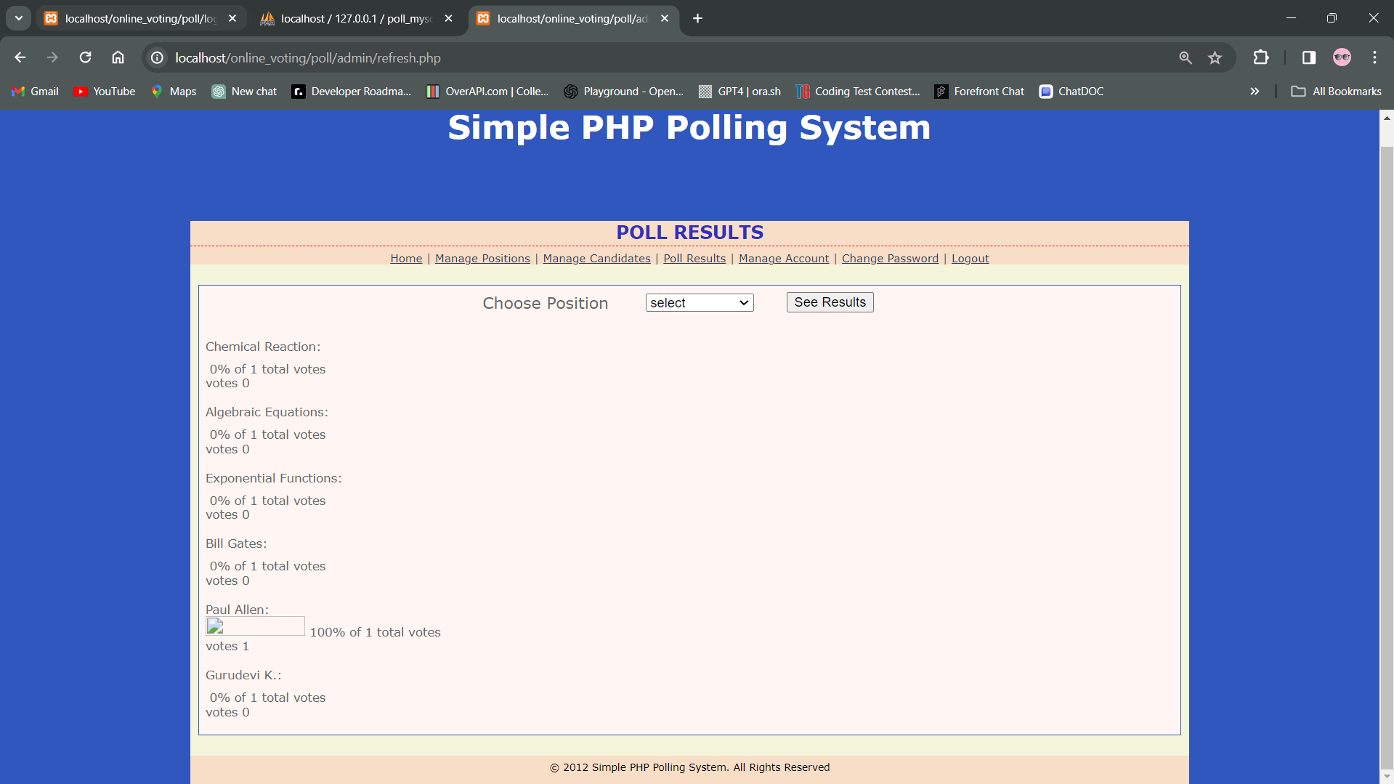

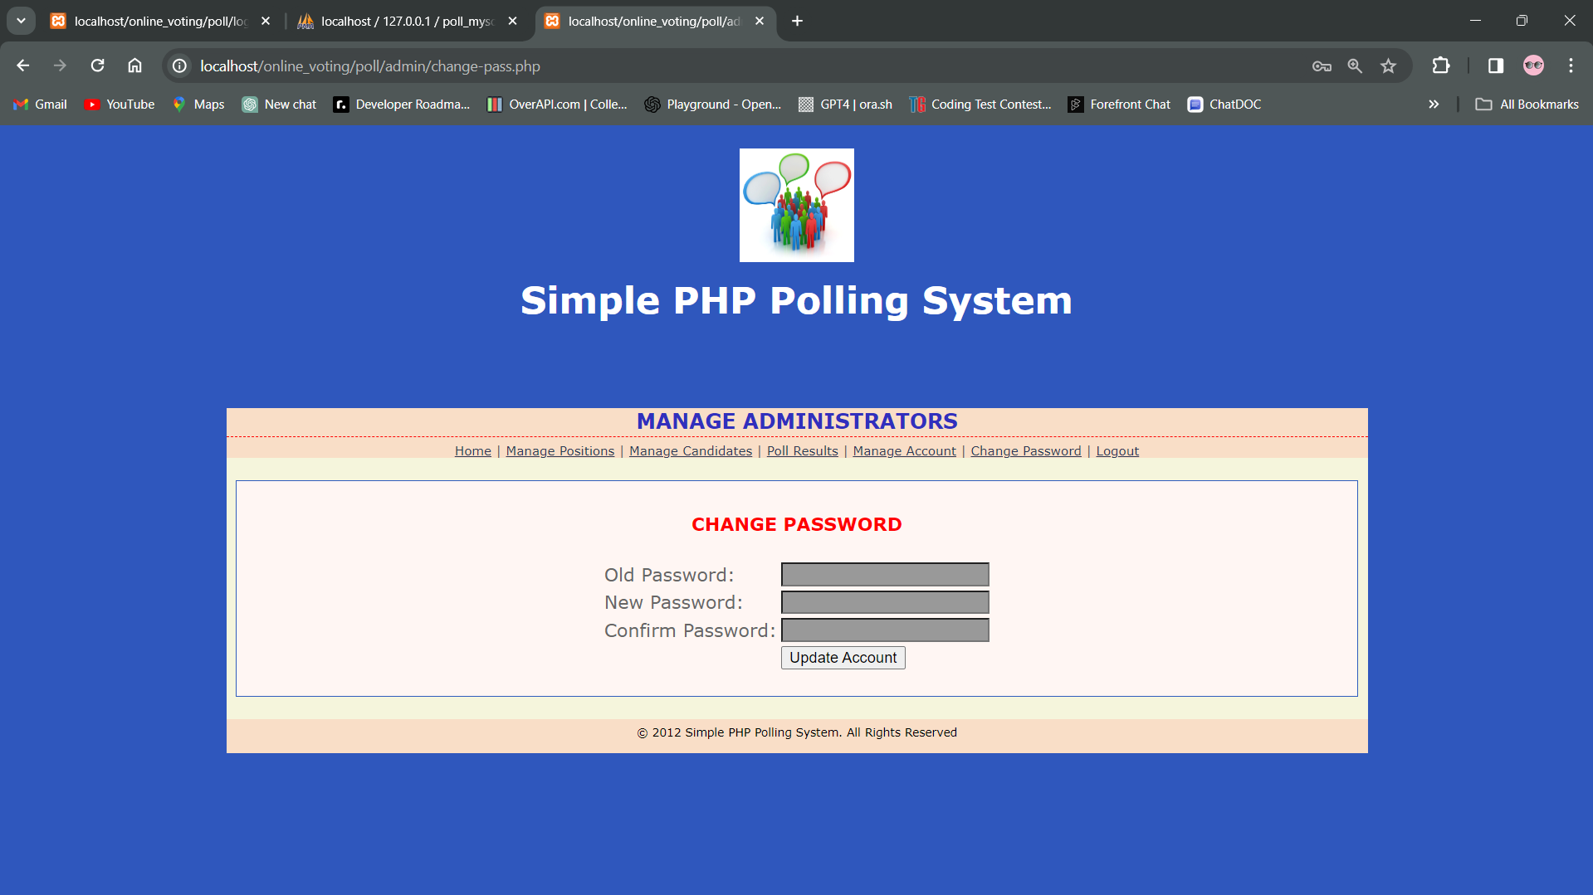 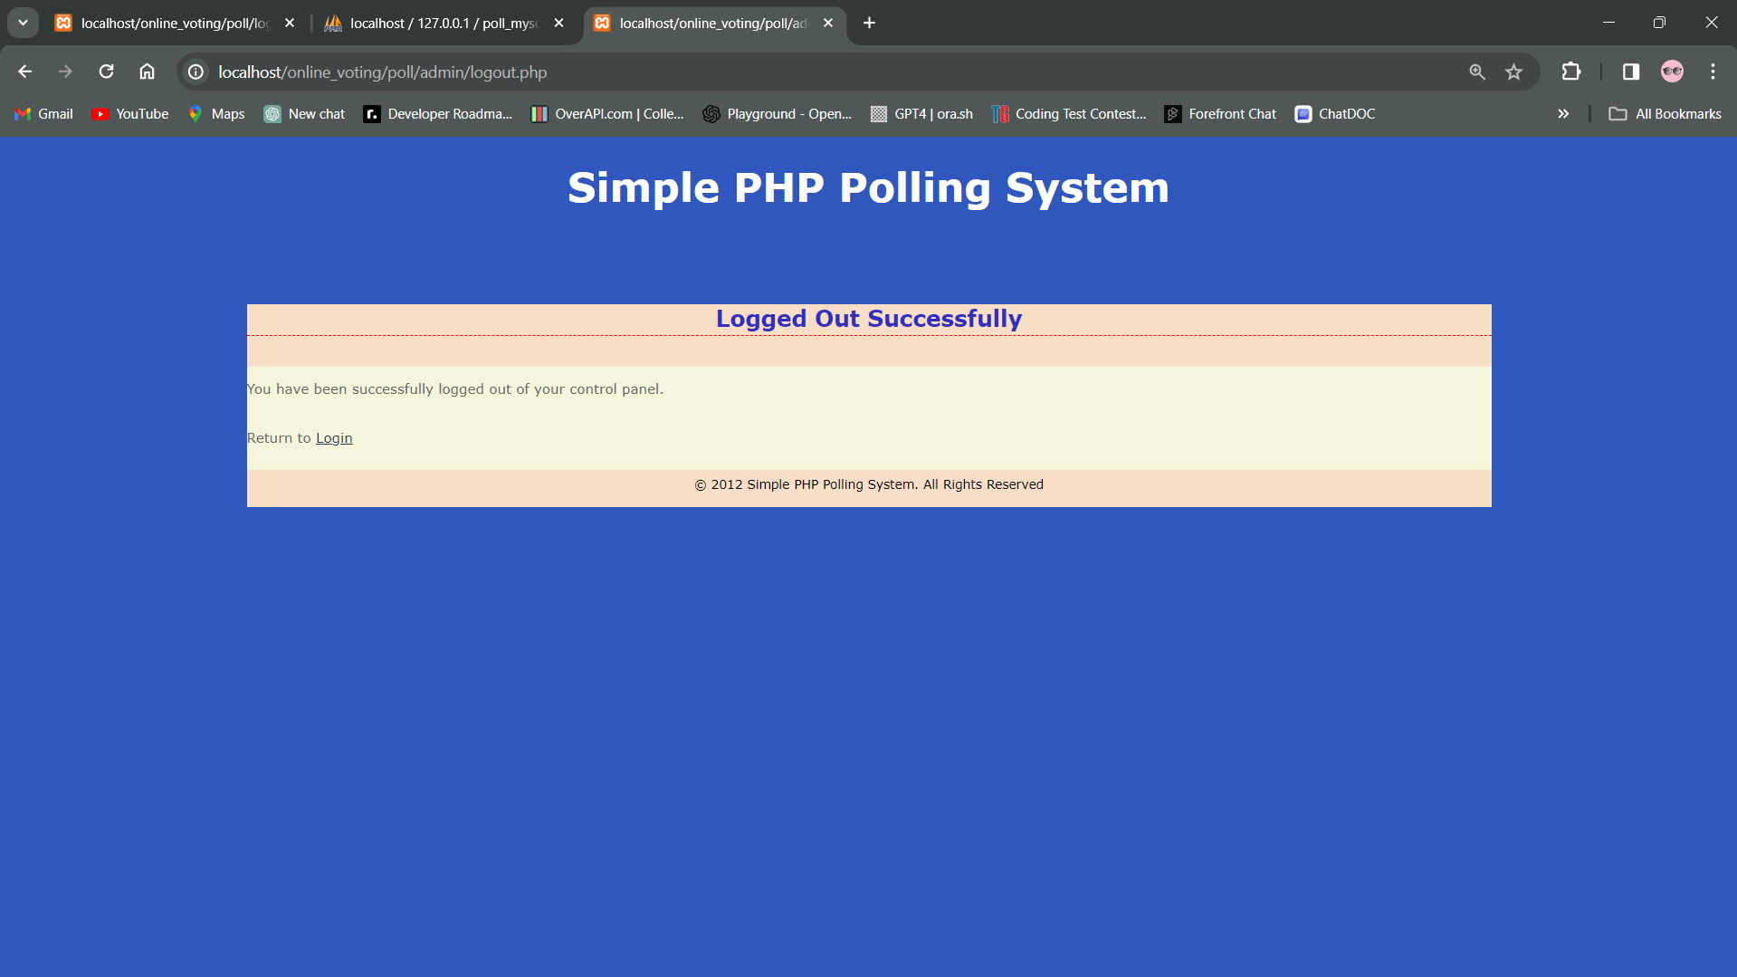

Fig 15.2 Admin Interface

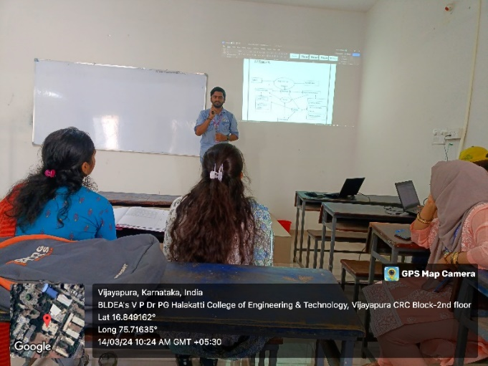 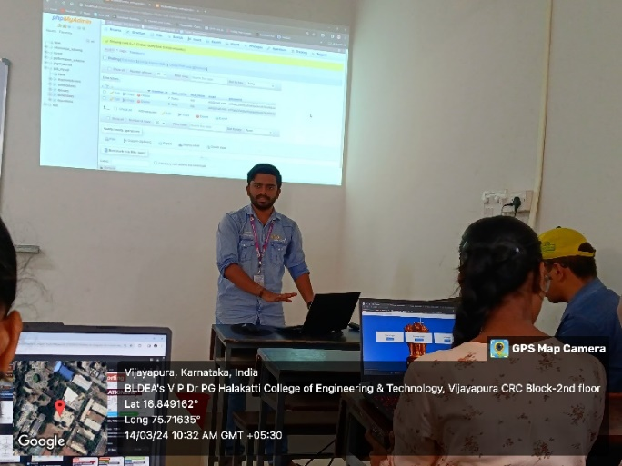

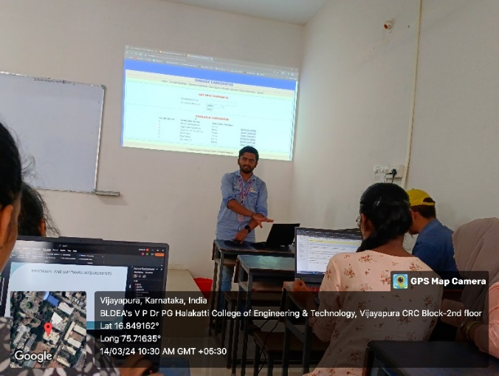 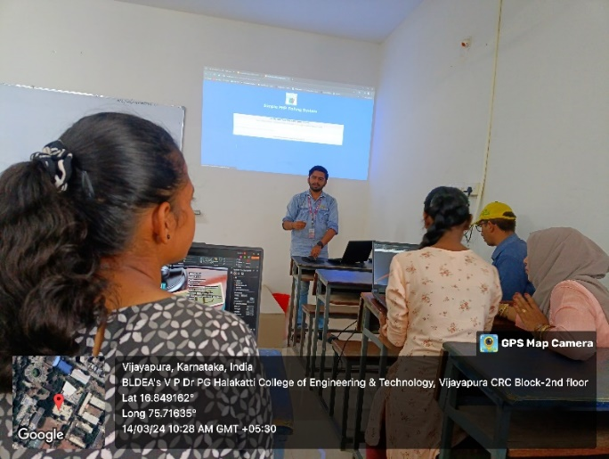

Fig 15.3 Presentation/Demo Day Photos